Olakunle Oluwadiya

ITIS 6320/8320

Homework 3

**MapReduce**

I began this assignment by creating a new keypair in AWS mapreduce.pem and converting to a .ppk file in putty keygen; so as to SSH into AWS via Putty.

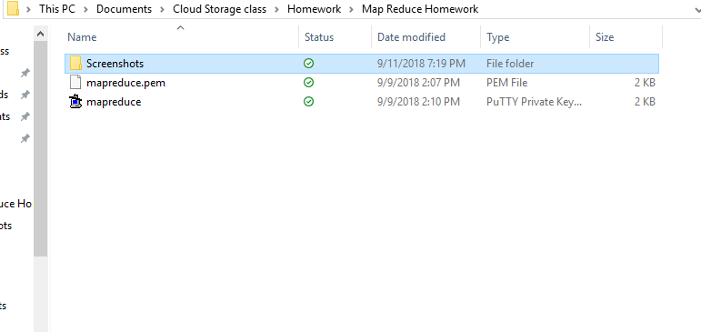

I launch a new Ubuntu t1.micro Linux instance.

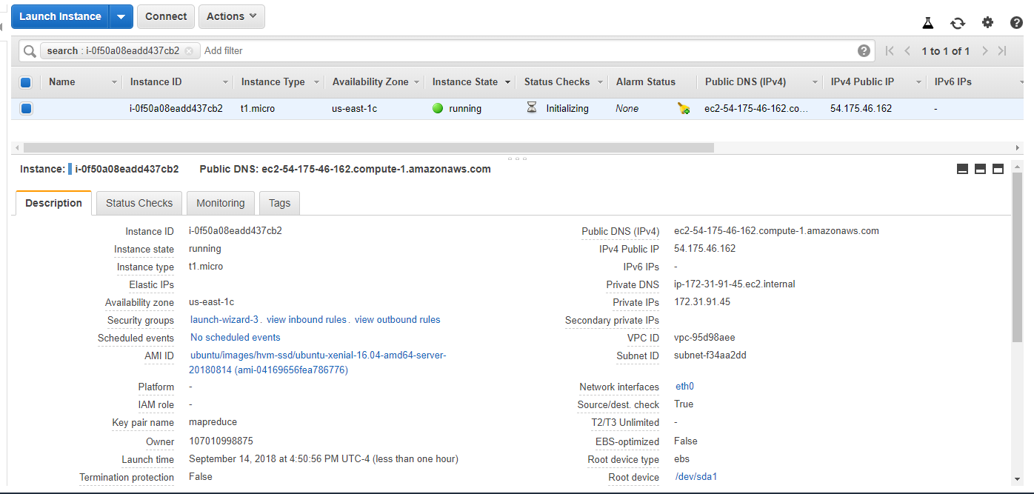

Using the Host name of my new instance, I SSH into the instance via Putty.

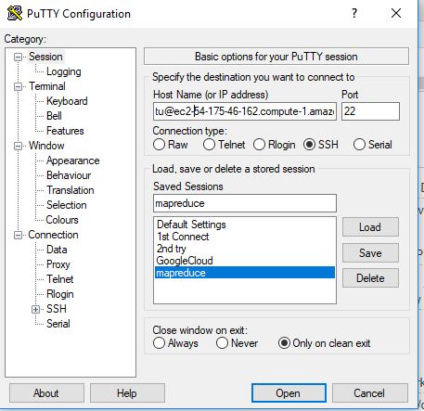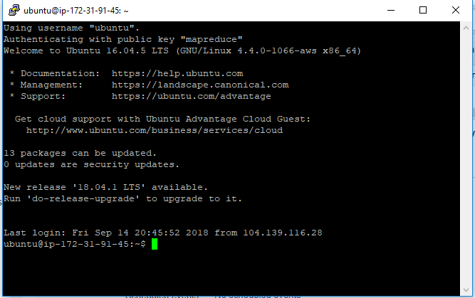

I enter the code provided in the assignment to import data & install Spark.

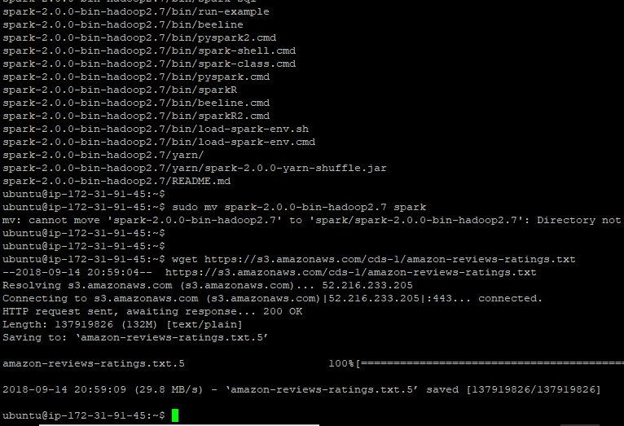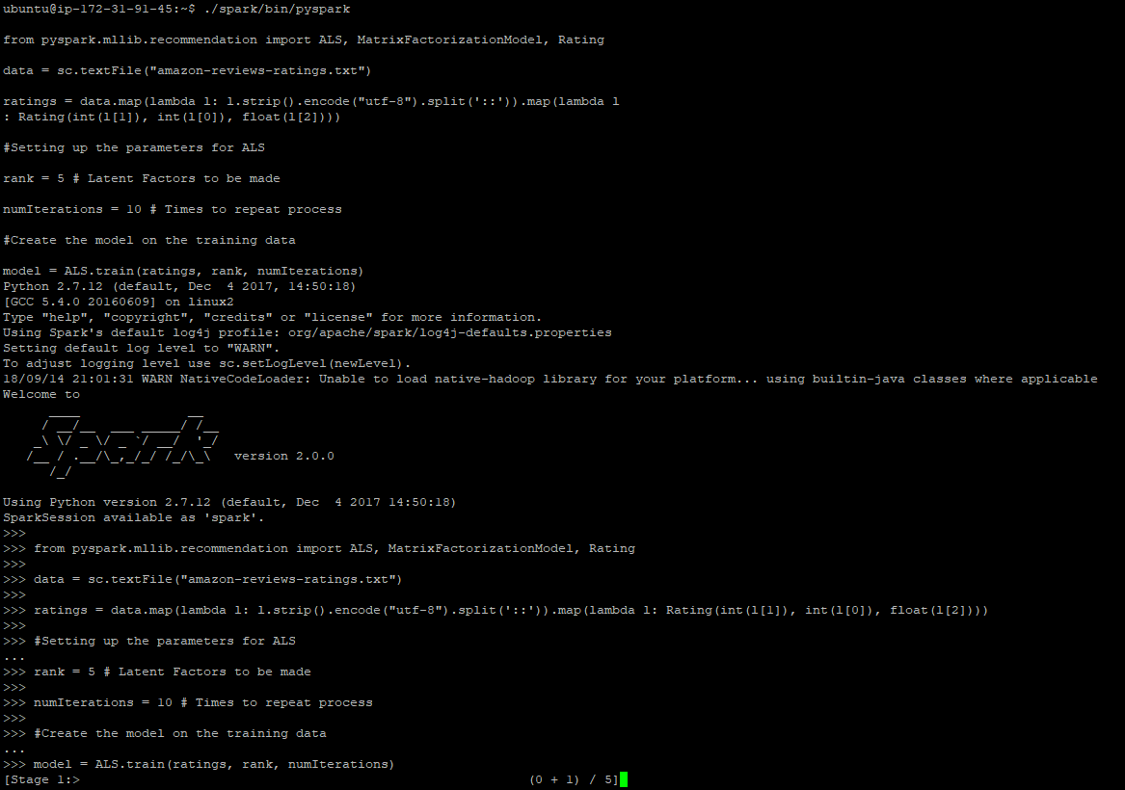

The code returns an insufficient Memory error.

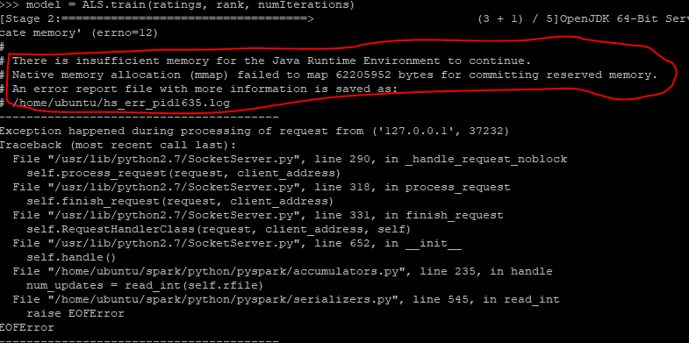

I exit out of Putty and stop the running instance. I proceeded to change the memory of the instance by changing the instance type from t1.micro to t2.small.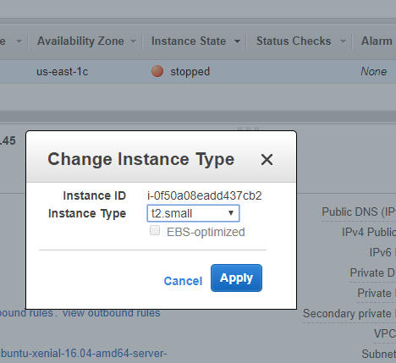

I launch the new t2.small instance, and SSH into the instance using the new Host ip address.

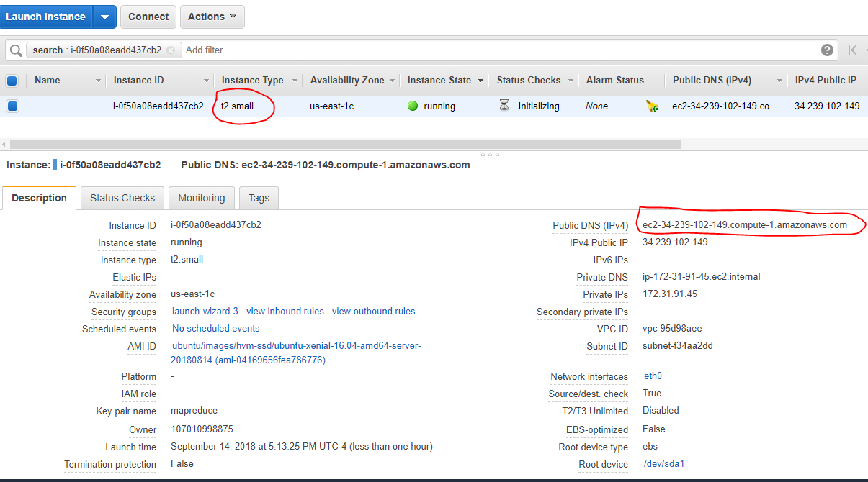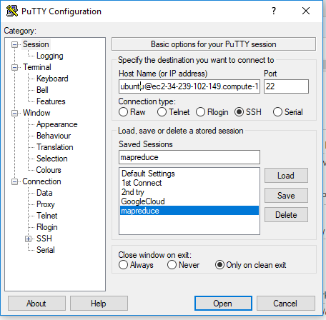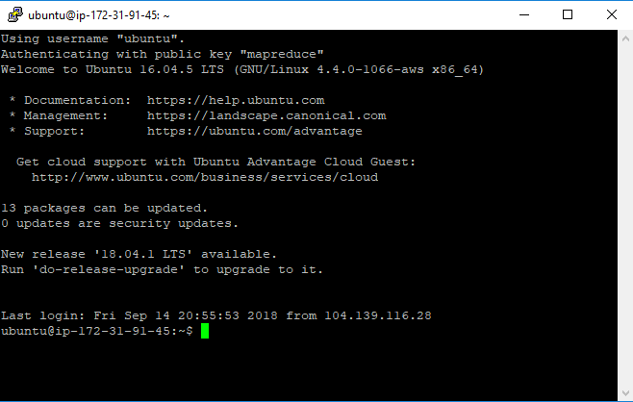

I re-enter the code provided in the assignment to import data & install Spark

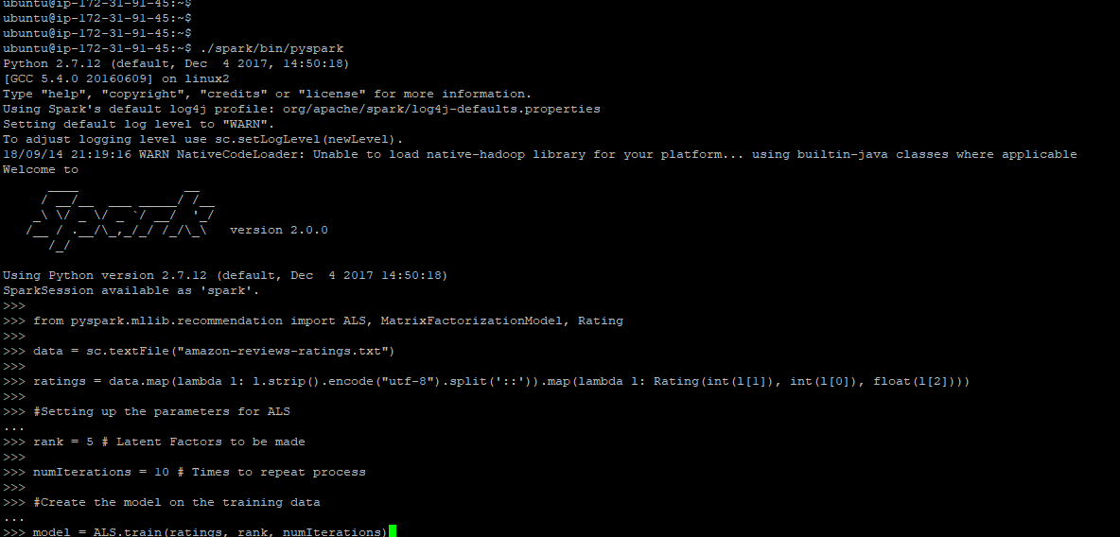

Though the code returned some errors in downloading certain data, there is enough memory to download the datasets needed to recommend 10 products for user 196.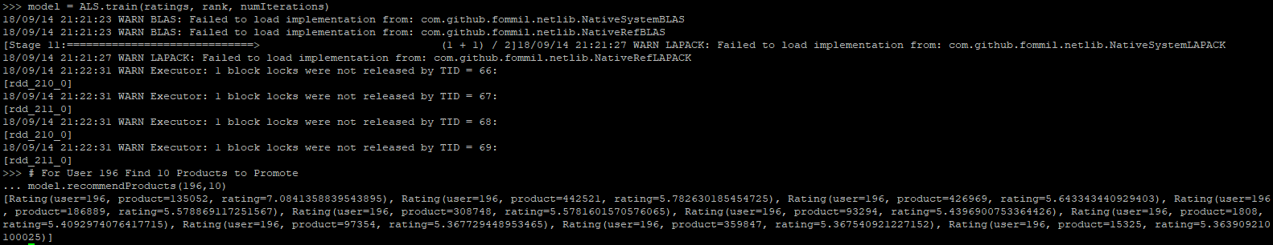

I was able to also recommend 10 products for user 112, and 23.

